- Kode program
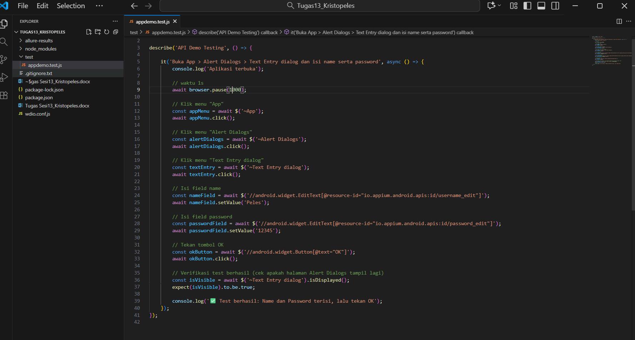
- Output cmd server
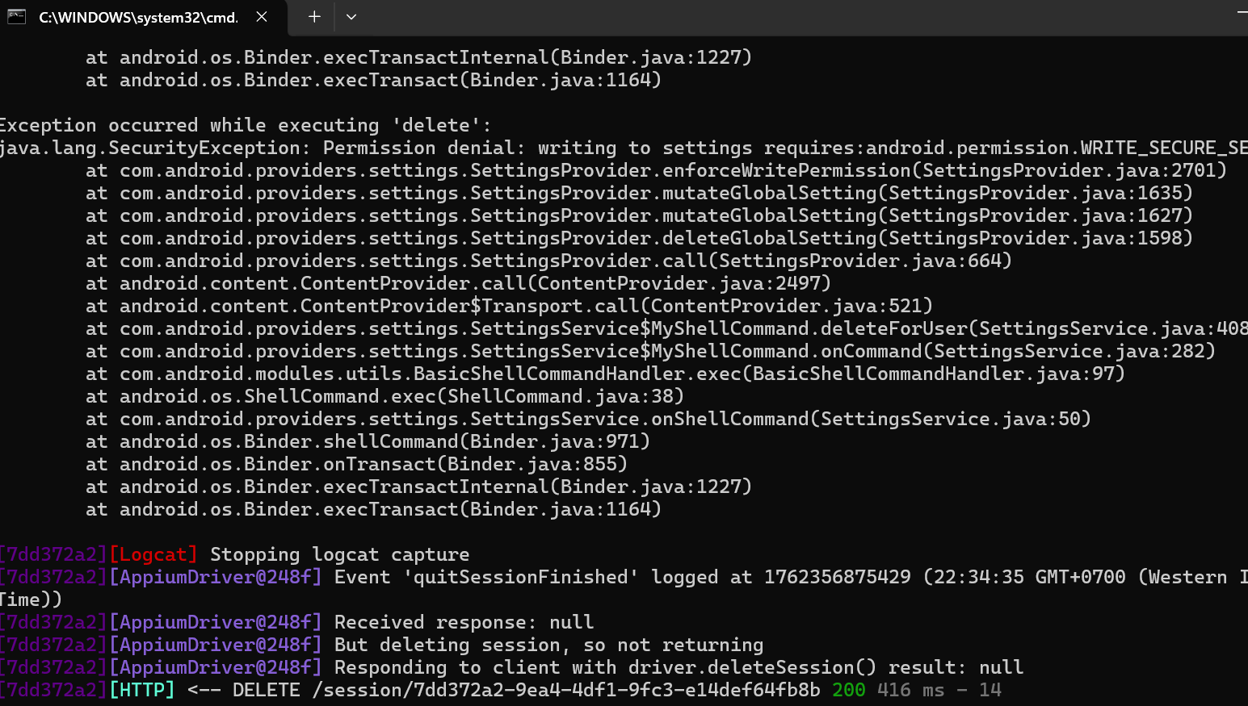
- Output cmd
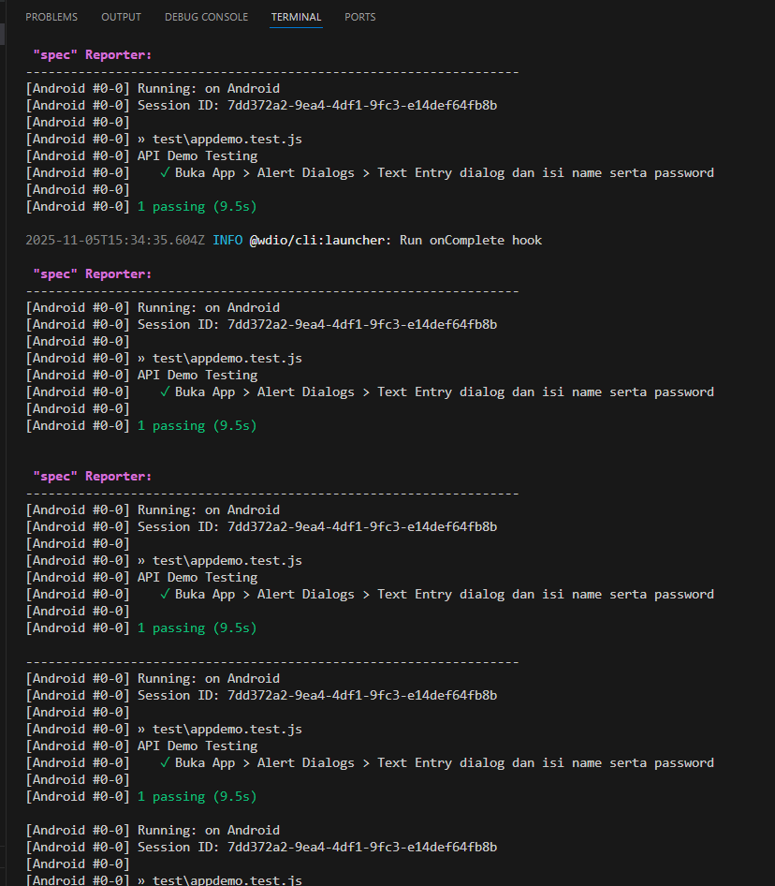
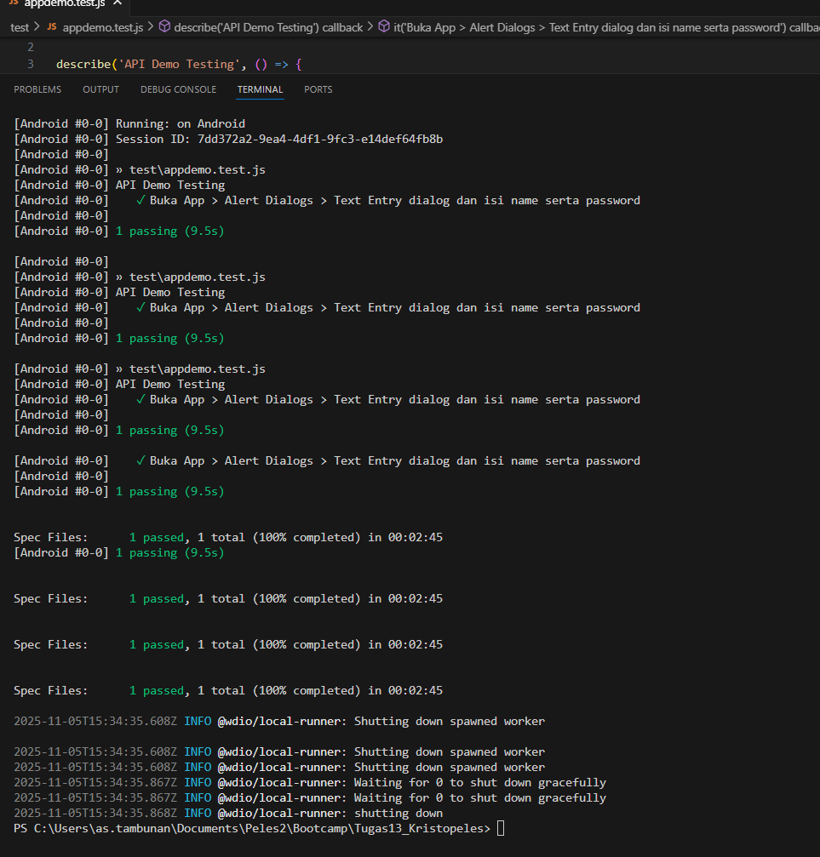
- Web allure
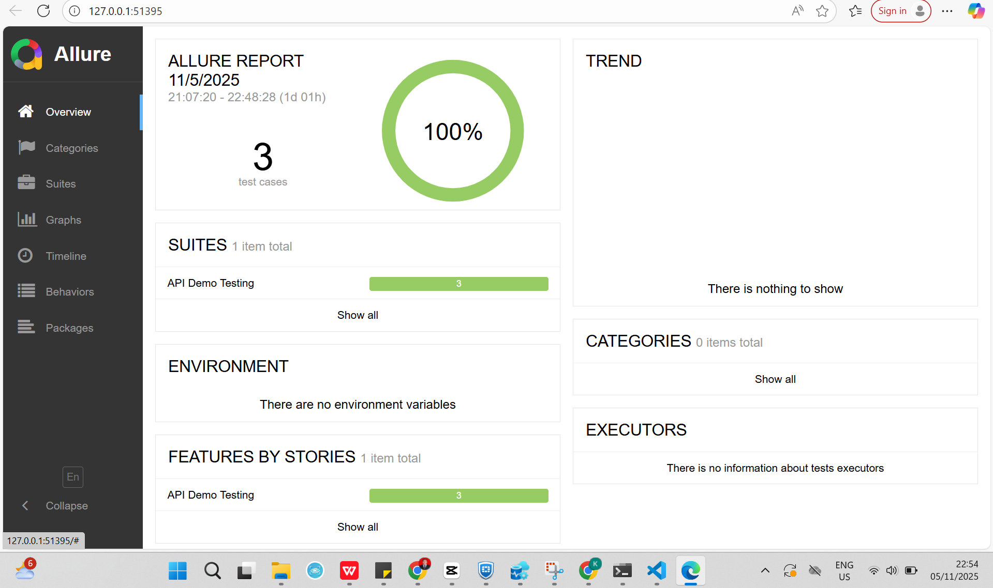

Link hithub:https://github.com/Peles10/Bootcamp/tree/df6d52568311abf60d5aa5bc0526da564fc5520c/Tugas13_Kristopeles

